1. In last section, we learnt how to create a docker image in order to run redis on our machine locally.
2. But still, there is a lot to learn about creating image in running docker app.
3. **Agenda**:
   1. We want create a node.js web app. Wrap it inside a docker container and then be able to access that web project from browser running on your local machine.
   2. We’re not worried about deploying the app right now.  
      We’re focused on getting node.js just to work inside of a docker container.
4. Let me first begin by showing you a quick outline of some of the steps that we’re going to follow.
   1. 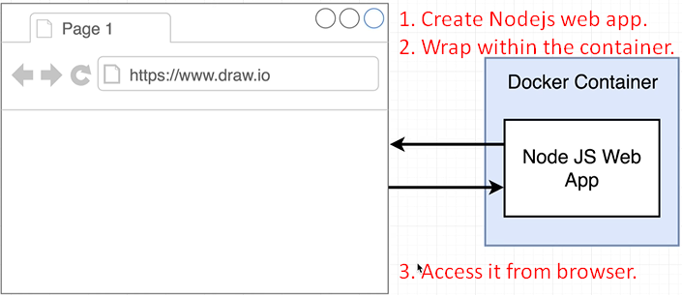
5. 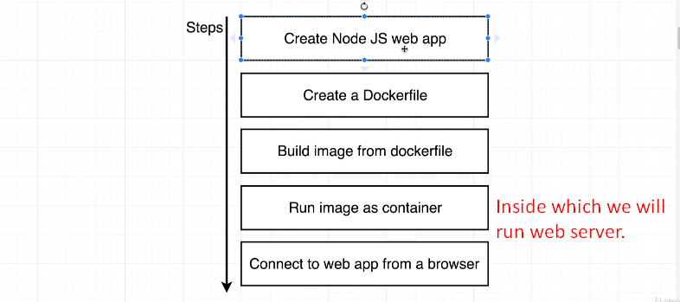  
   **Create a Dockerfile**: We’re going to create a dockerfile to create an image that is going to be used to run web server inside of a container.
6. 